# PHASE I requirements:

1) TUNAHAN ELUZ – KUTAY OLGUS

2) Gestation statistics. It can be very helpful for hospitals and some parents who will have children or who are willing to have a children.

https://drive.google.com/drive/folders/0B4vjJz9DRvExTHZlU05zaU9TQ2s?usp=sharing

3) **10 QUESTIONS**

1. What is the proportion between the premature births from the mothers who smoke to non-smokers?

2. What is the approximate annual income of the families that graduated from the university?

3. What is the proportion of the extramarital births?

4. How many percent of couples are interracial?

5. What is the proportion of the premature births given by the mother who gives more than 5 times to the others?

6. Can you align the 10 babies who have the longest pregnancy from the top weight to the down?

7. Can you compare normal weight and the pregnancy weight of mother?

8. Can you find the baby`s race according to father and mother`s race? (Show them all in a query. And order them by descending.)

9. Show the income depending on father`s education.(Show them both in a query. And order them by descending.)

10. Show mothers pregnancy weight according to baby`s birth_weight. (Show them both in a query. And order them by descending.)

4)

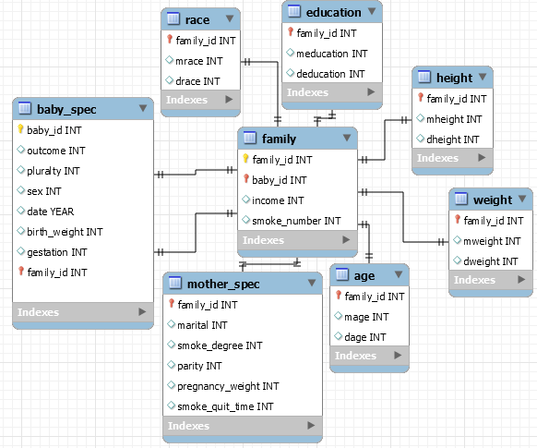

5) **10 QUESTIONS SQL**

*1-*

*create_view smoking_mother_gestation as*

*select count(smoke_degree) as var1*

*from mother_spec join family on (family.family_id = mother_spec.family_id)*

*where smoke_degree=1 and family.baby_id in(*

*select baby_id*

*from baby_spec*

*where gestation < 252);*

*create_view not_smoking_mother_gestation as*

*select count(smoke_degree) as var2*

*from mother_spec join family on (family.family_id = mother_spec.family_id)*

*where smoke_degree!=1 and family.baby_id in(*

*select baby_id*

*from baby_spec*

*where gestation < 252);*

*select smoking_mother_gestation.var1/not_smoking_mother_gestation.var2*

*from smoking_mother_gestation join not_smoking_mother_gestation;*

*2-*

*select avg(income)*

*from family join education on ( family.family_id = education.family_id)*

*where meducation = 5 and deducation = 5 ;*

*3-*

*create view not_married as*

*select count(marital) as var1*

*from mother_spec*

*where marital=1 ;*

*create view total_mother as*

*select count(marital) as var2*

*from mother_spec ;*

*select not_married.var1 * 100 / total_mother.var2*

*from not_married join total_mother*

*4-*

*create view interracial_couples as*

*select count(family_id) as var1*

*from race*

*where mrace != drace ;*

*create view couples as*

*select count (family_id) as var2*

*from race;*

*select interracial_couples.var1 * 100 / couples.var2*

*from interracial_couples join couples ;*

*5-*

*create view 5more_pregnancy as*

*select count(family_id) as var1*

*from mother_spec join family on (mother_spec.family_id = family.family_id)*

*where parity >= 5 and family.baby_id in (*

*select baby_id*

*from baby_spec*

*where gestation < 252);*

*create view 5less_pregnancy as*

*select count(family_id) as var2*

*from mother_spec join family on (mother_spec.family_id = family.family_id)*

*where parity <= 5 and family.baby_id in (*

*select baby_id*

*from baby_spec*

*where gestation < 252);*

*select 5more_pregnancy.var1 / 5less_pregnancy.var2*

*from 5more_pregnancy join 5less_pregnancy ;*

*6-*

*select \**

*from*

*(select birth_weight , gestation*

*from baby_spec*

*order by gestation desc*

*limit 10*

*) as sort*

*order by birth_weight desc ;*

*7-*

*select pregnancy weight , mweight*

*from mother_spec join family on(mother_spec.family_id = family.family_id)*

*where family.family_id in (*

*select family_id*

*from weight)*

*order by pregnancy_weight asc*

*limit 10;*

*8-*

*select smoke_degree , birth_weight*

*from mother_spec join family on (mother_spec.family_id = family.family_id)*

*where smoke_degree = 1 and family.baby_id in (*

*select baby_id*

*from baby_spec)*

*order by birth_weight desc*

*limit 10;*

*9-*

*select income , deducation*

*from family join education on ( family.family_id = education.family_id)*

*order by income desc*

*limit 10;*

*10-*

*select pregnancy_weight , birth_weight*

*from mother_spec join family on (mother_spec.family_id = family.family_id)*

*where family.baby_id in (*

*select baby_id*

*from baby_spec)*

*order by birth_weight desc*

*limit 10*;

6) We will load our database from csv file to mysql-workbench by using sql commands and workbench user interface. We are not planning to share our database throughout a web site.

7) We are not going to prepare a graphical user interface for our database project.

8) Intel core i5 4300u processor with AMD r5 m230 graphics card laptop which is using Mysql 6.3 workbench.